Shift Work Schedule MeSH Descriptor Data 2026
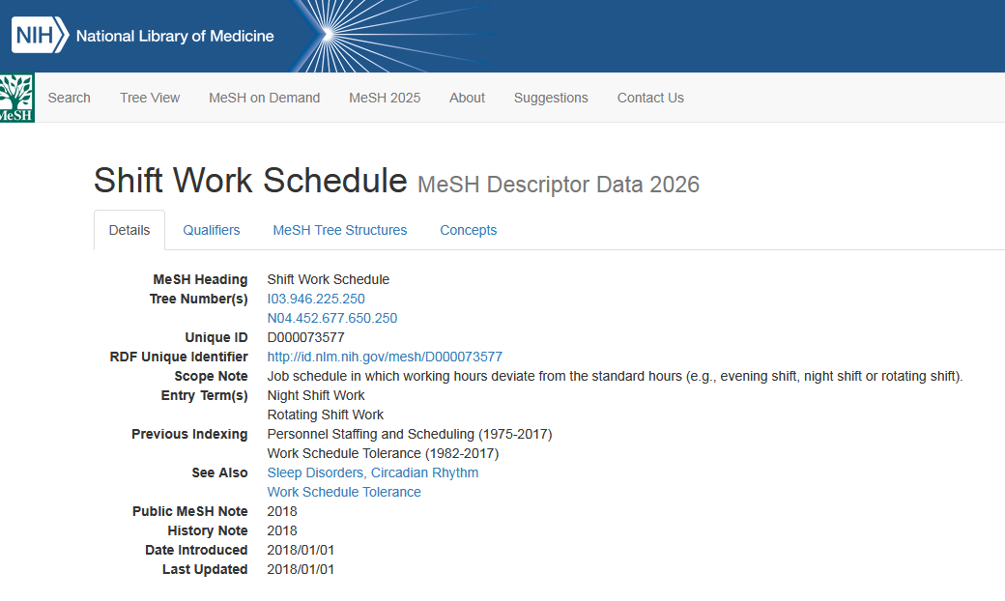

Circadian Rhythm MeSH Descriptor Data 2026
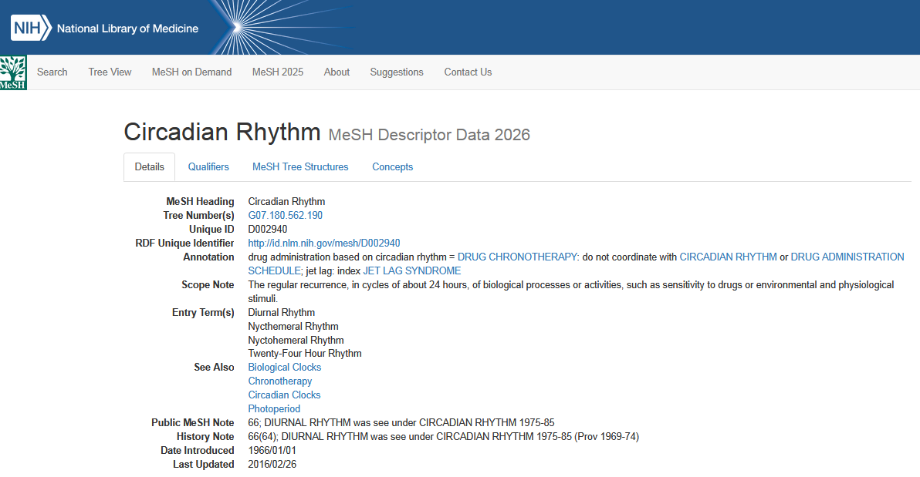

Essential Hypertension MeSH Descriptor Data 2026
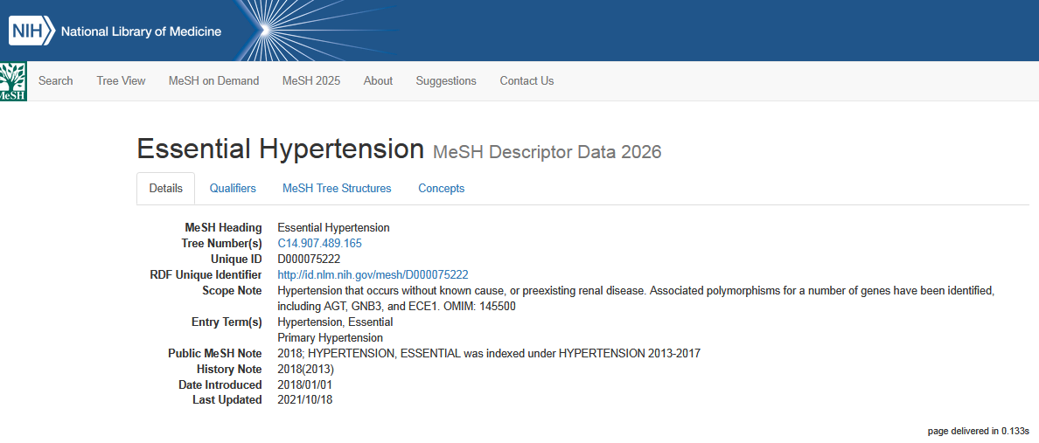

Insomnia, Fatal Familial MeSH Descriptor Data 2026
